 skene medical group 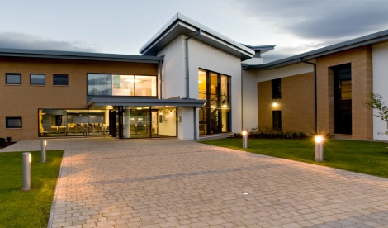
Salaried GP 4-6 sessions

We are expanding our GP team and are looking to recruit an additional salaried GP for 4-6 sessions.
Skene is a supportive, friendly and well managed practice with over 15,000 patients. Our ethos not only puts high quality multidisciplinary patient care at its centre but also prides itself in maintaining a cohesive and supportive team approach. Our Partner led Vision based practice is welcoming, forward thinking and proud to provide primary care from a purpose-built surgery situated 7 miles west of Aberdeen.
- Modern attractive, purpose-built premises including a staff gym. Easy access to the practice via AWPR
- 12 appointments per routine session (6 face to face, 6 telephone consultations)
- Duty team consisting of two GPs and ANP working together
- Low home visit numbers
- Robust multidisciplinary team comprising GPs, ANPs, pharmacotherapy team, physiotherapy, GPwSI dermatology, practice nurses, district nurses, health visitors. All co-located in same building making team working and communication easier
- Excellent management and administrative staff
- Strong educational ethos. Undergraduate teaching and training practice for GP trainees
- Specialist clinics: diabetes, coils, implants, minor surgery, joint injections, dermatology
- Daily mid-morning coffee catch up around 11:30 with good quality tea or coffee and chat
The successful candidate must have excellent clinical, communication, interpersonal and organisational skills.
Practice information can be found at www.skenemedicalgroup.co.uk, informal enquiries can be sent to gram.skeneadministrator@nhs.scot
To apply please send your CV along with a covering letter explaining what attracts you to this post and giving reasons why you consider yourself to be a suitable candidate to:
Nicola Elder, Practice Manager, e-mail: gram.skeneadministrator@nhs.scot
Closing date: 12th June 2026, we will regularly review applications and reserve the right to close an advert early if we identify a suitable candidate. To avoid disappointment, please submit your application as soon as possible.

